Adding the Travel Request Form to Your Google Drive

To add the Travel Request Form to your Google Drive, please click this link: https://docs.google.com/forms/d/1bWtdc8xfqg4V5fiAaa-DCU2QqPC-QMPRNRfpU4AYJOQ/copy

The link will open a new tab in your browser, which displays the following message:

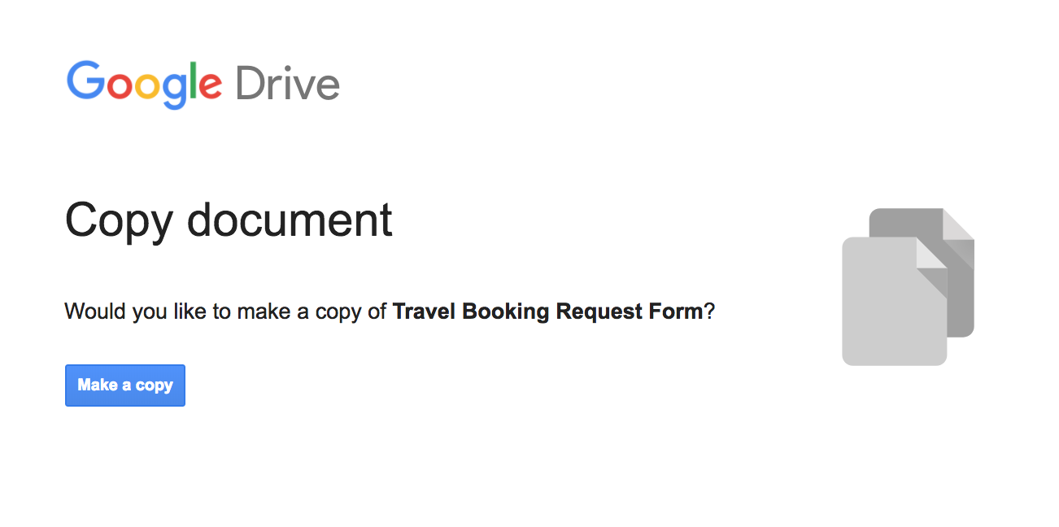

To add the form to your Google Drive, click the blue ‘Make a Copy’ button. You’ll then be taken to your copy of the form, with all of the travel request questions already added for you. If you want to customise your form or make any changes to the questions, feel free! It’s your copy to edit as you want.
Unfamiliar with Google forms? Click this link for the complete overview on how to edit, send and view responses: https://gsuite.google.com/learning-center/products/forms/get-started/

